Deja Carter, Daryan Lassiter, Akhari Haggard, Kiara Wilson

Weather App Function and Screenshots

1. This is the opening screen that users will see the home screen:

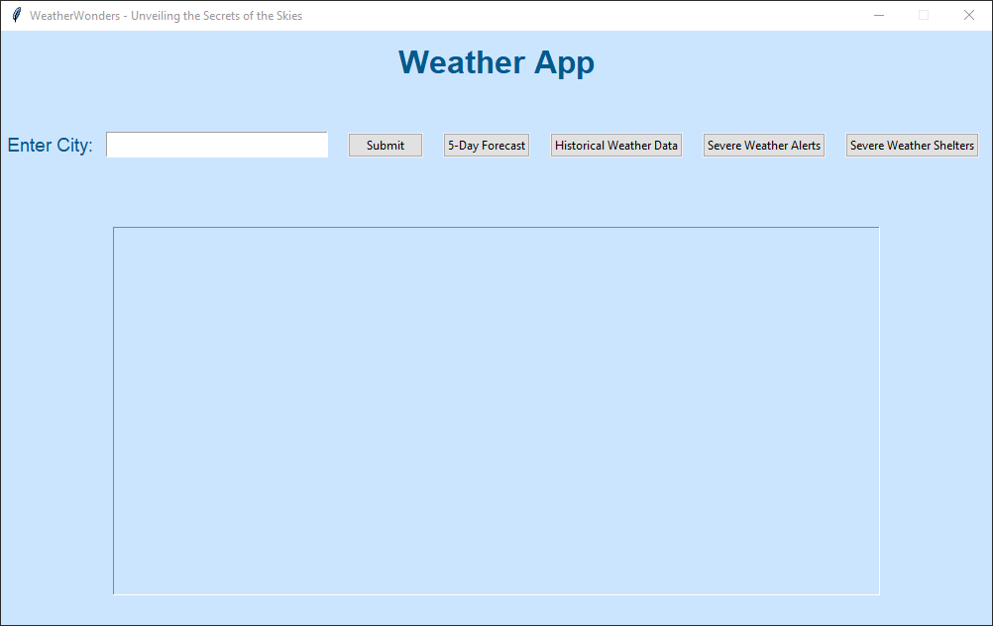

1. The user inputs the city of their choosing. However, the city has to be from the United States of America, or the information will not appear.

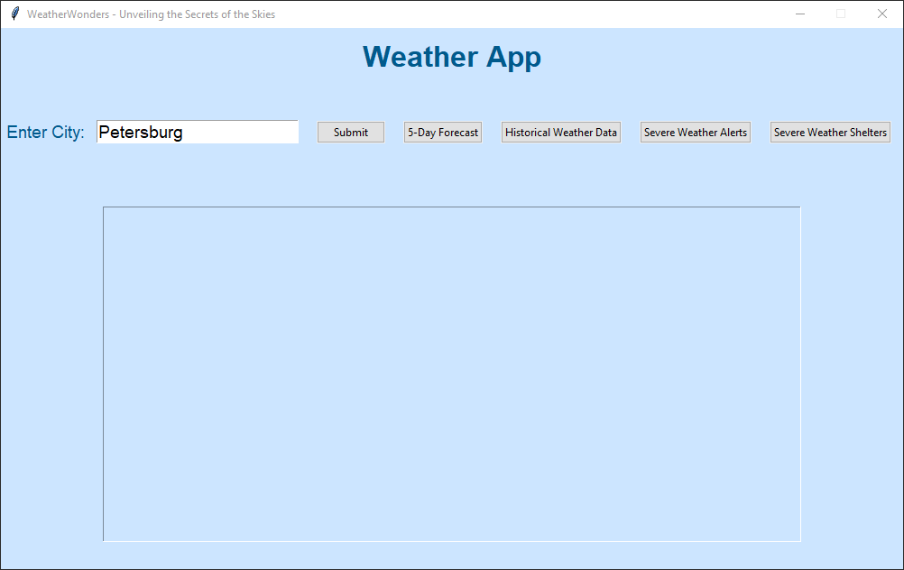

1. The weather app shows the users the temperature, clothing recommendations, humidity, pollen levels, air quality index, etc. Note: the air quality index and pollen levels are from the Ambee API where we are using a free trial for 15 days that expires on 11/25/23. We would need to create a new account and use the API key from the account.

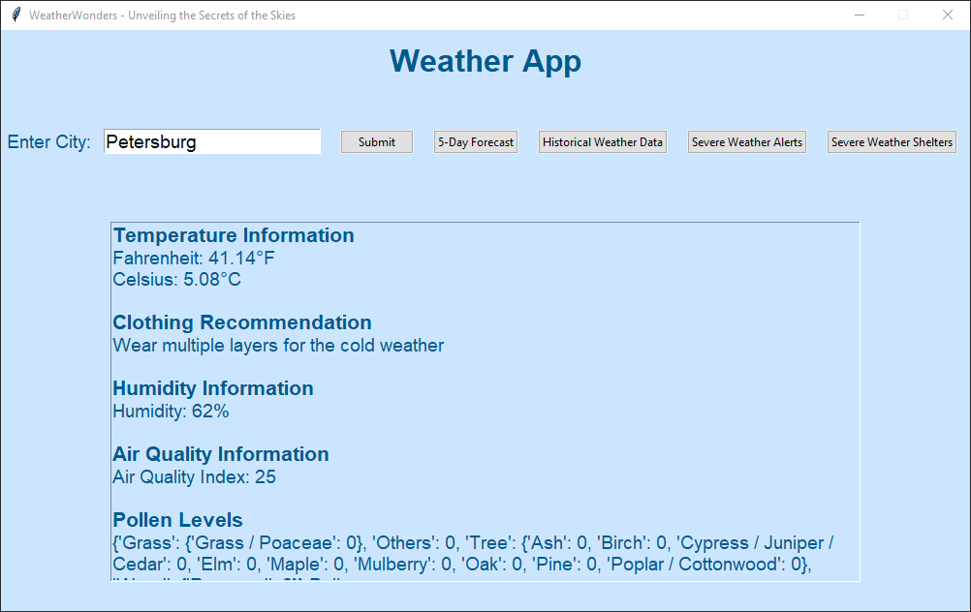

1. The users can click on the forest cast button which will make a new window appear with the 5-day forecast. The forecast will be 3 hourlies.

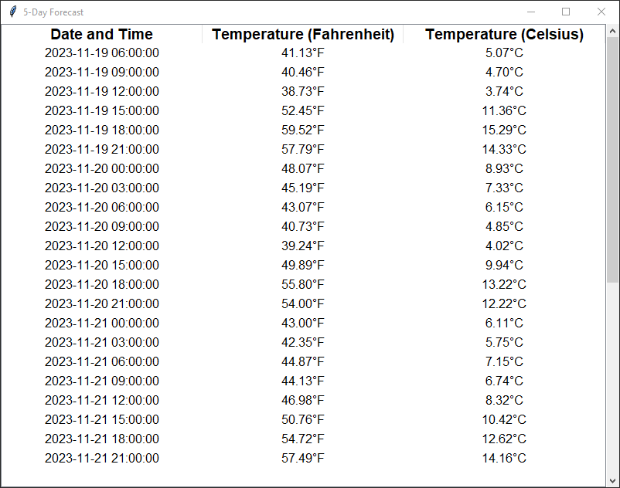

1. The user can click the historical weather data button to get historical data of that day. The historical weather data was supposed to show more, but the APIs to retrieve the data are not free. We are currently using a free trial that will end on 12/3/23. Currently, the historical data will show for the real-time date.

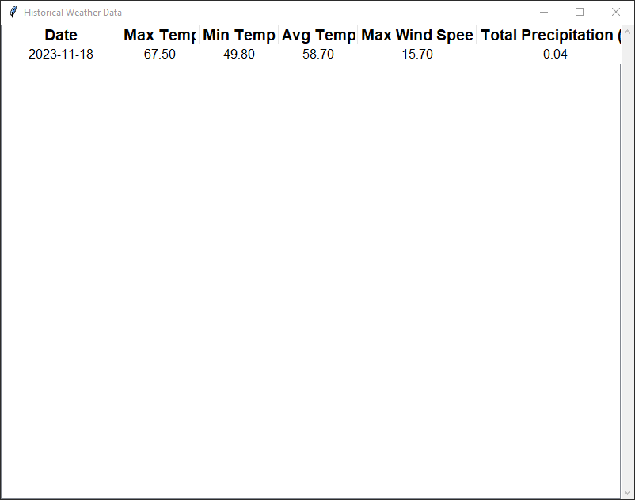

1. The users can also choose to click on severe weather alerts that will state severe weather. If there is no severe weather, it will say ‘No severe weather alerts for this city’.

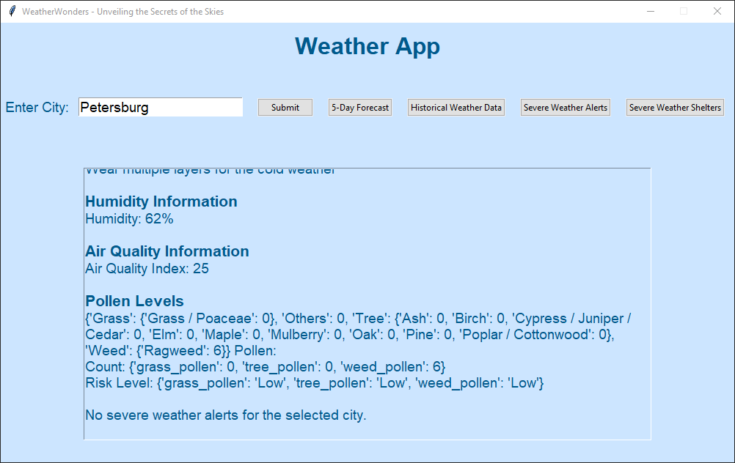

1. The user can click on severe weather shelters for shelters in their city. If there is no shelter or the code has an error, the weather will display, “No severe weather shelters found in the selected city.”

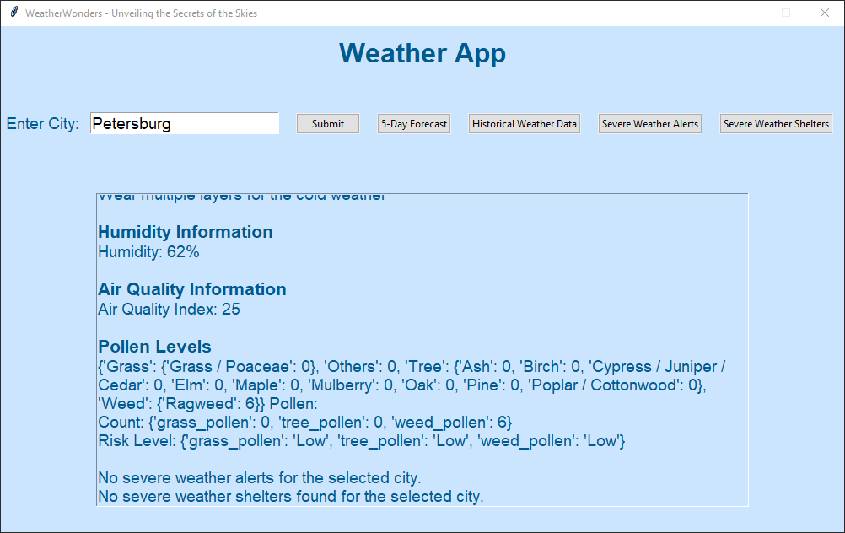

Conclusion:

The severe weather app uses real-time data from Python weather APIs. Most of the weather APIs are monthly subscriptions, but some have free trials or free API keys. However, there are limitations on what you can use with the API key per day.

If there are better APIs for weather data, we will implement the API into our project.